GOVERNMENT OF BALOCHISTAN

FINANCE DEPARTMENT

REQUEST FOR PROPOSAL (RFP)

Development, design & Implementation of Integrated Digital Transformation Systems

**RFP Reference No:** FD/IT/2025/001
**Date of Issue:** October 2025
**Issued by:** Finance Department, Government of Balochistan

TABLE OF CONTENTS
Section | Title
**1** | **INVITATION FOR PROPOSAL**
1.1 | Tender Notice
1.2 | Project Overview
**2** | **INSTRUCTIONS TO BIDDERS**
2.1 | Scope of Work
2.2 | Eligibility Criteria
2.3 | Bid Submission Process
**3** | **DETAILED SYSTEM REQUIREMENTS**
3.1 | Upgradation and new modules in Financial Management Information System (FMIS)
3.2 | Daak Management System (DMS)
3.3 | Pension Automation Management System (PAMS)
3.4 | Chief Minister Directive System (CMDS)
3.5 | Summaries Application System (SAS)
3.6 | digitalization/automation of pension cases of government of balochistan (gob) employees (online submission system)
**4** | **TECHNICAL SPECIFICATIONS**
4.1 | Technology Stack Requirements
4.2 | Integration Architecture
4.3 | Security Framework
4.4 | Infrastructure Requirements
**5** | **IMPLEMENTATION FRAMEWORK**
5.1 | Project Methodology
5.2 | Timeline and Milestones
5.3 | Quality Assurance
5.4 | Training and Support
**6** | **TERMS AND CONDITIONS**
6.1 | General Terms
6.2 | Intellectual Property
6.3 | Warranty and Support
**7** | **SUBMISSION REQUIREMENTS**
7.1 | Proposal Format
7.2 | Required Documents

SECTION 1: INVITATION FOR PROPOSAL

1.1 TENDER NOTICE
The Finance Department, Government of Balochistan, invites sealed bids from qualified, experienced, and reputable IT solution providers for the **Development & Implementation of Integrated Digital Transformation Systems**.

Project Details
Item | Details
**Project Title** | Development & Implementation of Integrated Digital Transformation Systems
**Procuring Agency** | Finance Department, Government of Balochistan
**RFP Reference No.** | FD/IT/2025/001
**Date of Issue** | October 2025
**Procurement Method** | Single Stage - Two Envelope Procedure (PPRA Rule 36(b))
**Source of Funds** | Government of Balochistan Budget

Key Dates
Event | Date/Timeline
**RFP Document Available From** | [Date to be announced]
**Pre-Bid Meeting** | [Date] at 11:00 AM
**Last Date for Queries** | [Date]
**Bid Submission Deadline** | [Date] at 02:00 PM
**Technical Bid Opening** | [Date] at 03:00 PM
**Financial Bid Opening** | To be announced after technical evaluation

Contact Information
Item | Details
**Contact Person** | Director IT, Finance Department
**Office Address** | Finance Department, Civil Secretariat, Quetta
**Phone** | +92-81-XXXXXXX
**Email** | it.finance@balochistan.gov.pk
**Website** | www.finance.balochistan.gov.pk

1.2 PROJECT OVERVIEW

Background and Context
The Finance Department, Government of Balochistan, is embarking on a comprehensive digital transformation initiative to modernize government operations and enhance service delivery to citizens. Currently, government processes rely heavily on manual, paper-based systems that result in:
- **Delays in service delivery** - Processing times of 3-6 months for routine matters
- **Limited transparency** - Difficulty in tracking file status and accountability
- **High operational costs** - Excessive paper consumption and storage requirements
- **Data fragmentation** - Inconsistent information across departments
- **Security vulnerabilities** - Risk of document loss, damage, or unauthorized access

Strategic Vision
The digital transformation initiative envisions a fully integrated, paperless government ecosystem where:
- All processes are automated with digital workflows
- Citizens access services online 24/7
- Real-time dashboards provide insights for decision-makers
- Inter-departmental coordination is seamless
- Data-driven policy making becomes standard practice

Systems to be Developed
This RFP covers the development and implementation of **FIVE (5)** integrated systems:
# | System Name | Acronym | Primary Function | Key Users
1 | Upgradation of Financial Management Information System (FMIS) | **FMIS** | Budget management, expenditure control, financial reporting | Finance Dept, All Departments, DDOs
2 | E-Filing Management System | **EFMS** | Digital document management, workflow automation, file tracking | All Government Departments
3 | Pension Automation Management System of GoB | **PAMS** | Pension processing, digitization of records, employee portal | Accountant General, Pension Dept, Employees
4 | Chief Minister Directive System | **CMDS** | Directive issuance, monitoring, execution tracking | CM Office, Principal Secretary, Departments
5 | Summaries/Note Application System | **SAS** | Summary preparation, approval workflows, decision tracking | All Departments, CM Office, Secretaries
6 | digitalization/automation of pension cases of government of balochistan (gob) employees (online submission system) |  | Automation of Pension Cases | All GOB employees

Expected Outcomes
Benefit Category | Target Improvement
**Processing Time** | 70% reduction in file processing time
**Cost Savings** | 80% reduction in paper consumption
**Transparency** | 100% audit trail for all transactions
**Accessibility** | 24/7 online access to government services
**Accuracy** | 95% reduction in manual errors
**User Satisfaction** | 85%+ satisfaction rate among users and citizens

SECTION 2: INSTRUCTIONS TO BIDDERS

2.1 SCOPE OF WORK
The selected vendor shall be responsible for the complete lifecycle of the project, including:

Core Deliverables
*Figure 1: Project Implementation Workflow - A comprehensive view of the development lifecycle from requirements analysis to ongoing support and maintenance.*

Detailed Scope Components
Component | Description | Key Activities
**1. Requirements Analysis** | Detailed study of existing processes | • Stakeholder workshops  • Process mapping  • Requirements documentation
**2. System Design** | Architecture and UI/UX design | • Technical architecture  • Database design  • Interface mockups
**3. Development** | Custom software development | • Frontend development  • Backend development  • API development
**4. Infrastructure Setup** | Hardware and network setup | • Server installation  • Network configuration  • Security implementation
**5. Data Migration** | Digitization and data transfer | • Document scanning  • Data extraction  • Data validation
**6. Testing** | Comprehensive QA | • Unit testing  • Integration testing  • UAT
**7. Training** | User capacity building | • Training materials  • Training sessions  • Documentation
**8. Deployment** | System go-live | • Phased rollout  • Production deployment  • Stabilization
**9. Support** | Post-implementation support | • Help desk  • Bug fixes  • Enhancements

Project Duration
**Total Duration:** 18-24 months from contract signing
Phase | Duration | Key Milestone
**Phase 1:** Planning & Design | Months 1-3 | Design Approval
**Phase 2:** Development & Testing | Months 4-15 | System Acceptance
**Phase 3:** Deployment & Training | Months 16-20 | Go-Live
**Phase 4:** Stabilization | Months 21-24 | Project Closure
**Phase 5:** Warranty & Support | 36 months post go-live | Ongoing Support

2.2 ELIGIBILITY CRITERIA

Mandatory Requirements
All bidders must meet the following minimum requirements to be eligible for participation:
# | Requirement | Mandatory/Desirable | Proof Required
1 | Registered company in Pakistan | **Mandatory** | BRA FBR
2 | Minimum 3 years in IT industry | **Mandatory** | Proof
3 | Registered for Income Tax & Sales Tax | **Mandatory** | NTN & STN Certificates
4 | Filed last 3 years tax returns | **Mandatory** | Tax return acknowledgments
5 | Not blacklisted by any government agency | **Mandatory** | Affidavit on stamp paper or letter head
6 | Completed at least 3 similar projects | **Mandatory** | Project completion certificates
7 | Minimum annual turnover PKR 100M (avg. last 3 years) | **Mandatory** | Turnover document

Financial Capacity
Criteria | Minimum Requirement | Verification Document
**Annual Turnover** | PKR 100 million per year (average of last 3 years) | Audited Financial Statements
**Net Worth** | PKR 50 million | Latest Audited Balance Sheet
**Bank Credit Line** | PKR 30 million | Bank Statement / Credit Facility Letter
**Liquidity** | Positive cash flow for last 2 years | Bank Statements

Technical Capability: Bidders must demonstrate:

- Experience in **enterprise system development** using .NET Core/Blazor
- Proven expertise in **mobile application development** (Flutter or React Native)
- Experience with **AI/ML integration** for document generation
- Knowledge of **government workflows** and processes
- Experience in **large-scale data digitization** projects (minimum 100,000 documents)
- Capability to provide **24/7 support** with dedicated teams

2.3 BID SUBMISSION PROCESS

Bid Security
Item | Details
**Amount** | Offered cost
**Form** | Bank Draft / Pay Order / Bank Guarantee
**Validity** | 90 days from bid submission date
**Payable To** | Director Finance, Government of Balochistan
**Refund** | Within 30 days after contract award (for unsuccessful bidders)

⚠️ **Note:** Bids without valid bid security will be rejected.

Submission Format
Two-Envelope System:
┌─────────────────────────────────────────┐
│ OUTER ENVELOPE │
│ │
│ RFP No: FD/IT/2025/001 │
│ Company Name: [Your Company] │
│ "NOT TO BE OPENED BEFORE [DATE]" │
│ │
│ ┌─────────────────────────────────┐ │
│ │ ENVELOPE 1: TECHNICAL PROPOSAL │ │
│ │ • Company Profile │ │
│ │ • Technical Approach │ │
│ │ • Implementation Plan │ │
│ │ • Team CVs │ │
│ │ • All Required Documents │ │
│ └─────────────────────────────────┘ │
│ │
│ ┌─────────────────────────────────┐ │
│ │ ENVELOPE 2: FINANCIAL PROPOSAL │ │
│ │ • Detailed Pricing │ │
│ │ • Payment Terms │ │
│ │ • Cost Breakdown │ │
│ └─────────────────────────────────┘ │
│ │
└─────────────────────────────────────────┘

Submission Details
Item | Details
**Submission Method** | In person or by registered mail
**Submission Address** | Director IT, Finance Department, Civil Secretariat, Quetta
**Deadline** | [Date] at 02:00 PM
**Late Submissions** | Will be rejected and returned unopened
**Bid Validity** | 120 days from date of opening

Important Instructions
1. ✓ Submit **5 hard copies** of technical proposal + **2 USB drives** with PDF
2. ✓ Submit **2 hard copies** of financial proposal + **1 USB drive** with Excel/PDF
3. ✓ All pages must be **numbered and signed**
4. ✓ Use **company letterhead** for all documents
5. ✓ Provide **certified copies** of all certificates
6. ✓ Include **original reference letters** from previous clients
7. ✓ Ensure **authorized signatory** signs all documents

SECTION 3: DETAILED SYSTEM REQUIREMENTS

3.1 FINANCIAL MANAGEMENT INFORMATION SYSTEM (FMIS)

System Overview
FMIS will revolutionize budget management and financial operations across the Government of Balochistan by automating the entire budget allocation and expenditure control process.

Core Workflow
*Figure 2: FMIS Budget Approval Workflow - Multi-level approval process from DDO initiation to fund release, ensuring transparency and accountability in budget allocation.*

Functional Requirements

3.1.1 Budget Management Module
Feature | Description | Priority
**Demand Request Management** | Digital submission and tracking of budget demands by DDOs | **High**
**Multi-Level Approval Workflow** | Automated routing through Department Secretary → Finance Secretary → S/O | **High**
**Budget Allocation Tracking** | Real-time visibility of budget utilization across departments | **High**
**Budget Revision Management** | Process for supplementary demands and re-appropriations | **High**
**Funds Release Management** | Electronic release orders and fund transfer instructions | **High**

3.1.2 User Roles and Permissions
Role | Responsibilities | Access Level
**DDO (Drawing & Disbursing Officer)** | • Submit demand requests  • Track approval status  • View allocated budget | Department Level
**Department Secretary** | • Review demand requests  • Approve/reject/send back for revision  • Monitor departmental budget | Department Level + Review Authority
**Finance Department Secretary** | • Final approval of demands  • Budget oversight  • Policy decisions | Province-wide + Final Authority
**S/O (Section Officer)** | • Process approved demands  • Release funds  • Generate release orders | Province-wide + Execution Authority
**System Administrator** | • User management  • System configuration  • Report generation | Full System Access

3.1.3 Dashboard and Analytics
Executive Dashboard Components:
Widget | Metrics Displayed | Update Frequency
**Budget Overview** | Total budget, allocated, utilized, available | Real-time
**Pending Approvals** | Count by stage, aging analysis | Real-time
**Department-wise Analysis** | Allocation vs utilization by department | Daily
**Trend Analysis** | Historical spending patterns, forecasts | Weekly
**Alert Center** | Overdue approvals, budget threshold alerts | Real-time

3.1.4 Technical Specifications
Component | Specification | Technology
**Frontend (Web)** | Responsive web application with rich dashboard | **.NET Core + Blazor**
**Backend** | RESTful API architecture | **.NET Core Web API**
**Mobile App** | Native-quality mobile experience for Android & iOS | **Flutter or React Native**
**Database** | Enterprise-grade RDBMS | **PostgreSQL / SQL Server**
**Authentication** | Secure authentication with role-based access | **OAuth 2.0 / JWT**
**Reporting** | Advanced reporting engine | **Crystal Reports / SSRS**

3.1.5 Mobile Application Features
The FMIS mobile application will provide:
- **On-the-go approvals** - Approve/reject demands from mobile devices
- **Real-time notifications** - Push notifications for pending actions
- **Dashboard access** - View key metrics and analytics
- **Document viewing** - Access supporting documents
- **Biometric authentication** - Fingerprint/Face ID support
- **Offline capability** - View cached data without internet
- **Digital signatures** - Sign approvals electronically

3.1.6 Integration Requirements
Integration Point | Purpose | Method
**E-Filing System** | Link budget demands to relevant files | RESTful API
**Pension System** | Verify pension payment budgets | RESTful API
**Accountant General** | Financial reconciliation | SOAP/REST Web Services
**Banking System** | Payment processing | Secure File Transfer

3.1.7 Reporting Requirements
Standard Reports:
Report Name | Description | Frequency
Budget Allocation Report | Department-wise budget allocation | On-demand
Expenditure Analysis | Actual spending vs budget | Monthly
Pending Approvals Report | Status of all pending demands | Daily
DDO Performance Report | Processing time by DDO | Weekly
Variance Analysis | Budget vs actual analysis | Quarterly

3.2 Daak Management System (DMS)

System Overview
DMS will create a paperless office environment by digitizing the entire file movement and correspondence workflow. The system will integrate AI-powered document generation and provide complete transparency in file tracking.

System Architecture
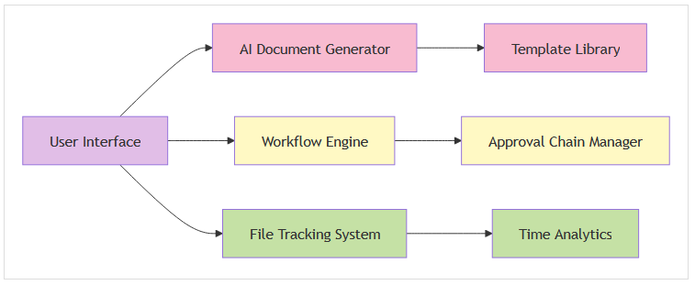

Core Workflow
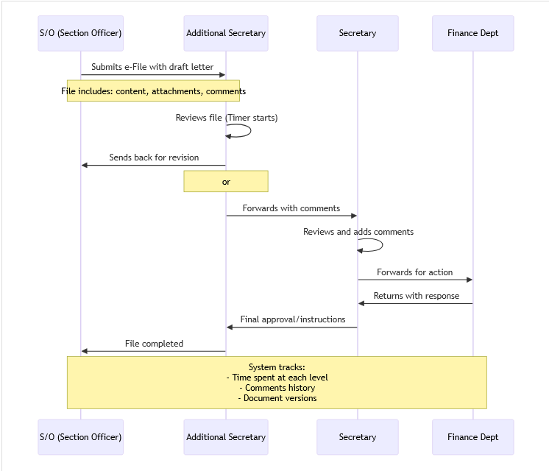

Functional Requirements

3.2.1 Core Features
Feature | Description | Priority
**AI-Powered Draft Generation** | Generate letters/requests from text prompts using government templates | **High**
**Digital File Movement** | Track files through approval chain with complete transparency | **High**
**Time Tracking** | Automatic timer for how long each user held the file | **High**
**Comment System** | Add comments, annotations, and instructions on files | **High**
**Version Control** | Track all changes and maintain document history | **High**
**Template Library** | Pre-loaded government templates for all document types | **High**
**Search and Retrieval** | Powerful search across all files and documents | **Medium**
**Audit Trail** | Complete history of all actions on every file | **High**

3.2.2 AI Document Generation
The AI-powered document generator will:
User Input: "I need to request 5 new vehicles for the department"

AI Process:
1. Analyze user intent
2. Select appropriate government template
3. Auto-populate:
- Official letter format
- Department details
- Standard clauses
- Proper formatting
4. Generate draft with proper structure

Output:
Fully formatted official letter with:
✓ Proper subject line
✓ Reference numbers
✓ Standard government language
✓ Required justifications
✓ Proper closing

Technical Implementation:
Component | Technology | Purpose
**NLP Engine** | GPT-based models or similar | Understand user prompts
**Template Engine** | Custom-built | Merge AI output with govt templates
**Language Models** | Fine-tuned on govt documents | Generate formal government language

3.2.3 File Tracking Metrics
The system will track and display:
Metric | Description | Visibility
**Time at Each Level** | How long file remained with each user | All users in chain
**Processing Time** | Actual working time vs idle time | Supervisors + Admin
**Comments History** | All comments in chronological order | All users in chain
**Route History** | Complete path taken by file | All users
**Average Processing Time** | Benchmarks by file type | Management
**Bottleneck Analysis** | Users/departments causing delays | Management + Admin

3.2.4 Document Types Supported
Document Type | Use Case | Template Available
**Demand Request** | Budget allocation requests | ✓
**Official Letter** | Inter-departmental correspondence | ✓
**Order/Notification** | Official orders and notifications | ✓
**Summary** | Executive summaries | ✓
**Memo** | Internal memorandums | ✓
**Note Sheet** | Internal noting | ✓
**Circular** | General circulars | ✓

3.2.5 Integration with FMIS
EFMS will be **fully integrated** within the FMIS dashboard:
FMIS Dashboard
├── Budget Management (Core FMIS)
├── E-Filing Module (Integrated EFMS)
│ ├── My Files
│ ├── Create New File
│ ├── Pending Actions
│ ├── Search Files
│ └── Reports
├── Reports
└── Settings
Shared Features:
*. Single sign-on (SSO) *. Unified notification system
*. Common user management *. Integrated reporting

3.2.6 Technical Specifications
Component | Technology Stack
**Backend** | .NET Core (same as FMIS)
**Frontend** | Blazor (integrated with FMIS)
**AI/ML Components** | Python-based microservices (FastAPI)
**Document Storage** | Azure Blob Storage / MinIO
**Database** | Same as FMIS (shared schema)

3.2.7 Performance Requirements
Metric | Target | Measurement Method
**File Creation Time** | < 30 seconds | System timer
**AI Letter Generation** | < 10 seconds | API response time
**File Movement** | Instant (< 1 second) | System latency
**Search Results** | < 2 seconds | Query execution time
**Concurrent Users** | 5,000+ simultaneous users | Load testing
**System Availability** | 99.5% uptime | Monitoring tools

3.3 PENSION AUTOMATION MANAGEMENT SYSTEM (PAMS)

System Overview
PAMS will comprehensively transform pension management through:
1. **Digitization** of 105,000 existing pension files and 248,000 employee records
2. **Digital Portal** for employees to apply for pension online
3. **Automation** of pension calculation and processing

System Components

Detailed Requirements

3.3.1 Legacy Records Digitization
Scope of Digitization:
Category | Quantity | Average Pages | Total Pages (Est.)
**Existing Pension Files** | 105,000 files | 50 pages/file | 5,250,000 pages
**Employee Service Records** | 248,000 records | 30 pages/record | 7,440,000 records
**Total Estimated** | 353,000 files | - | **12,690,000 pages**

Digitization Process:

Technical Requirements:
Requirement | Specification
**Scanning Resolution** | Minimum 300 DPI, 600 DPI for detailed documents
**Image Format** | PDF/A (archival quality) with embedded text layer
**OCR Accuracy** | Minimum 95% accuracy with manual verification for critical fields
**Indexing** | Full-text search capability with metadata tagging
**Storage** | Redundant storage with backup and disaster recovery
**Access Speed** | Document retrieval in < 3 seconds

Metadata Schema:
Field | Type | Mandatory | Searchable
Employee ID | Text | ✓ | ✓
Employee Name | Text | ✓ | ✓
CNIC | Text | ✓ | ✓
Department | Text | ✓ | ✓
Designation | Text | ✓ | ✓
Date of Joining | Date | ✓ | ✓
Date of Retirement | Date | ✓ | ✓
Document Type | Text | ✓ | ✓
Scan Date | Date | ✓ | ✓
File Location | Text | ✓ | ✗

3.3.2 Employee Self-Service Portal
Portal Capabilities:
Feature | Description | User Type
**Profile Management** | View and update personal information | All Employees
**Service History** | View complete service record | All Employees
**Pension Application** | Apply for pension in last year of service | Retiring Employees
**Application Status** | Real-time tracking of pension application | Applicants
**Document Upload** | Upload required documents | Applicants
**Pension Calculator** | Estimate pension amount | All Employees
**Grievance System** | Submit and track complaints | Pensioners
**Digital Records Access** | View scanned service records | All Employees

Pension Application Workflow:
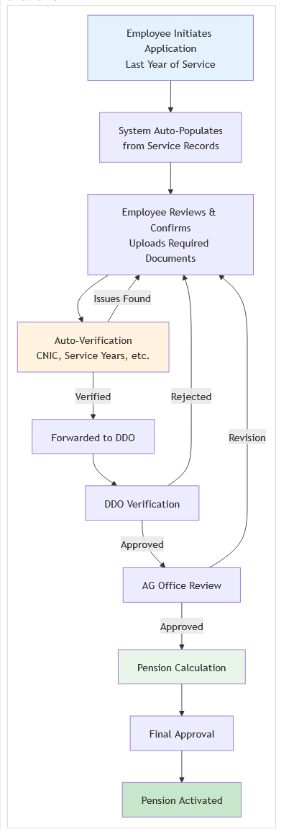

Application Simplification:
Traditional Process (Manual):
- Visit office multiple times: 5-10 visits
- Submit physical documents: 15-20 documents
- Wait for processing: 3-6 months
- Follow up repeatedly: Uncertain
Digital Process (PAMS):
- Online application: Single session
- Upload documents: One-time upload
- Auto-verification: Instant
- Track status: Real-time updates
- Processing time: **2-4 weeks** (target)

3.3.3 Automated Pension Calculation Engine
Supported Pension Types:
Pension Type | Calculation Basis | Complexity
Superannuation Pension | Normal retirement at age limit | Medium
Voluntary Retirement Pension | Early retirement with benefits | Medium
Invalid Pension | Medical retirement | High
Family Pension | Death of employee/pensioner | High
Commutation | Lump sum payment option | High

Calculation Parameters:
Parameter | Source | Validation
Qualifying Service | Service records | Auto-verified
Average Emoluments | Last 12 months salary | Auto-calculated
Pension Rules | Government regulations | Pre-configured
Commutation Factor | Age-based tables | Auto-applied
Deductions | Outstanding dues | Verified with Finance

3.3.4 Technical Specifications
Component | Technology | Purpose
**Backend** | .NET Core | Core processing logic
**Frontend Web** | Blazor / ASP.NET MVC | Employee portal
**Document Storage** | MinIO / Azure Blob Storage | Store scanned documents
**OCR Engine** | Tesseract / Commercial OCR | Text extraction
**Database** | PostgreSQL / SQL Server | Store metadata and records
**Search Engine** | Elasticsearch | Full-text search
**Workflow Engine** | Custom .NET Core | Approval workflows

3.4 CHIEF MINISTER DIRECTIVE SYSTEM (CMDS)

System Overview
CMDS is a specialized **mobile-first platform** exclusively designed for the Chief Minister to:
- Issue directives instantly to departments
- Monitor implementation in real-time
- Receive status updates and reports
- Ensure swift action on government priorities

System Workflow
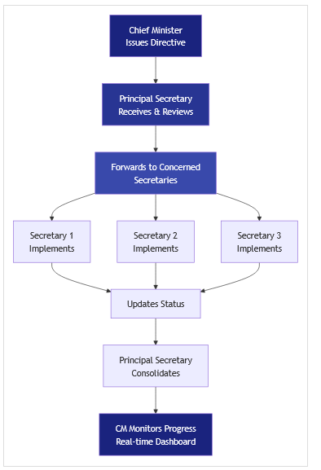

Functional Requirements

3.4.1 Chief Minister Mobile App
Key Features:
Feature | Description | Priority
**Directive Creation** | Create and send directives via mobile | **Critical**
**Voice-to-Text** | Dictate directives using voice input | **High**
**Template Selection** | Quick directives from pre-defined templates | **High**
**Rich Media Support** | Attach photos, documents, audio notes | **High**
**Real-time Dashboard** | View status of all directives at a glance | **Critical**
**Push Notifications** | Instant alerts for status updates | **Critical**
**Secure Authentication** | Biometric + PIN-based security | **Critical**
**Offline Mode** | Draft directives without internet | **Medium**

User Interface Design Principles:
- **Extreme Simplicity** - Designed for executive users, minimal training required
- **Large Touch Targets** - Easy to use in various conditions
- **Clear Visual Hierarchy** - Most important information prominently displayed
- **Minimal Steps** - Issue directive in 3 taps or less
- **Dark Mode Support** - Comfortable viewing in all lighting conditions

3.4.2 Directive Management
Directive Categories:
Category | Use Case | Priority Level
**Policy Directive** | New policy implementation | High
**Operational Directive** | Specific action required | Medium
**Inquiry Directive** | Request for information/report | Medium
**Emergency Directive** | Urgent action required | **Critical**
**Follow-up** | Check progress on previous directive | Low
Directive Properties:
Property | Description | Mandatory
**Subject** | Brief title of directive | ✓
**Category** | Type of directive | ✓
**Priority** | Critical / High / Medium / Low | ✓
**Recipients** | Secretaries to receive directive | ✓
**Deadline** | Expected completion date | ✓
**Description** | Detailed instructions | ✓
**Attachments** | Supporting documents | ✗
**Follow-up** | Link to related directives | ✗

3.4.3 Monitoring Dashboard
Dashboard Widgets:
┌─────────────────────────────────────────────┐
│ 📊 DIRECTIVE OVERVIEW │
├─────────────────────────────────────────────┤
│ Total Directives: 250 │
│ ✓ Completed: 180 (72%) │
│ ⏳ In Progress: 50 (20%) │
│ ⚠️ Overdue: 15 (6%) │
│ ⏸️ Pending: 5 (2%) │
└─────────────────────────────────────────────┘

┌─────────────────────────────────────────────┐
│ 📈 DEPARTMENT PERFORMANCE │
├─────────────────────────────────────────────┤
│ ✅ Finance Dept: 95% on-time │
│ ✅ Education Dept: 88% on-time │
│ ⚠️ Health Dept: 72% on-time │
│ ❌ Works Dept: 65% on-time │
└─────────────────────────────────────────────┘

┌─────────────────────────────────────────────┐
│ 🔔 RECENT UPDATES │
├─────────────────────────────────────────────┤
│ • Finance Secretary: Directive #245 │
│ completed - Budget approved │
│ • Education Secretary: Update on │
│ Directive #223 - Schools audit in │
│ progress (65% complete) │
│ • Health Secretary: Directive #198 │
│ overdue - Action required │
└─────────────────────────────────────────────┘

3.4.4 Recipient Functionality
Secretary/Principal Secretary App Features:
Feature | Description
**Receive Directives** | Get instant notification of new directives
**View Details** | Access full directive with attachments
**Update Status** | Provide progress updates (percentage, milestones)
**Upload Reports** | Submit completion reports and evidence
**Request Extension** | Request deadline extension with justification
**Add Comments** | Communicate issues or challenges
**Forward to Teams** | Assign to subordinates with instructions

3.4.5 Technical Specifications
Component | Technology | Rationale
**Mobile App (CM)** | **Flutter** or **React Native** | Cross-platform iOS/Android support
**Mobile App (Recipients)** | **Flutter** or **React Native** | Consistent experience
**Backend API** | **.NET Core Web API** | Integration with other systems
**Database** | **PostgreSQL / SQL Server** | Reliable data storage
**Push Notifications** | **Firebase Cloud Messaging** | Real-time alerts
**Authentication** | **OAuth 2.0 + Biometric** | Maximum security
**Cloud Storage** | **Azure / AWS** | Store attachments

3.4.6 Security Requirements
Given the sensitive nature of CM directives:
Security Measure | Implementation
**End-to-End Encryption** | All communications encrypted
**Biometric Authentication** | Mandatory fingerprint/face recognition
**Device Binding** | App tied to specific authorized devices
**Session Management** | Auto-logout after inactivity
**Audit Logging** | Complete trail of all actions
**Remote Wipe** | Ability to wipe data from lost devices
**Secure Storage** | Encrypted local storage on devices

3.5 SUMMARIES APPLICATION SYSTEM (SAS)

System Overview
SAS will automate and streamline the preparation, review, and approval of executive summaries - critical documents that enable high-level decision-making in government.

What is a Summary?
Definition:
A summary is an official document prepared by a department and sent to the Chief Minister, Chief Secretary, or a Minister for approval, decision, or information on a particular issue.
Purpose:
- Obtain policy decisions from CM or Cabinet
- Seek approval of new schemes, projects, or financial allocations
- Request administrative sanctions (posts, transfers, rule changes)
- Forward proposals for legislation or regulation changes
- Provide updates on ongoing initiatives

System Workflow

Functional Requirements

3.5.1 Summary Creation Module
Intelligent Creation Features:
Feature | Description | Technology
**Template Library** | Pre-defined templates for all summary types | Built-in
**AI Content Assistance** | Help draft summaries from key points | NLP/GPT-based
**Auto-Population** | Pull data from FMIS, PAMS, EFMS automatically | API Integration
**Formatting Tools** | Rich text editor with government formatting | WYSIWYG Editor
**Version Control** | Track all revisions and changes | Built-in
**Collaborative Editing** | Multiple users can contribute | Real-time sync

Summary Types:
Type | Purpose | Template Available
**Policy Summary** | New policy proposals | ✓
**Financial Summary** | Budget/expenditure approvals | ✓
**Administrative Summary** | Administrative decisions | ✓
**Project Summary** | Project approvals | ✓
**Legislative Summary** | Law/rule amendments | ✓
**Information Summary** | Briefings for CM | ✓

3.5.2 Approval Workflow
Multi-Stage Review Process:
Workflow Features:
Feature | Description
**Automatic Routing** | System routes based on summary type and rules
**Parallel Reviews** | Multiple reviewers can review simultaneously
**Comments & Annotations** | Add comments without changing original text
**Track Changes** | See all modifications by each reviewer
**Digital Signatures** | Secure electronic signatures at each stage
**Email Notifications** | Auto-notify stakeholders of status changes
**Escalation** | Auto-escalate if review pending too long

3.5.3 Integration Requirements
System | Data Shared | Purpose
**FMIS** | Budget data, financial allocations | Auto-populate financial information
**EFMS** | Related files and documents | Attach supporting documentation
**PAMS** | Employee/pension data | Include relevant employee information
**CMDS** | Link to related directives | Track directive implementation

3.5.4 Analytics and Reporting
Summary Analytics Dashboard:
Metric | Description | Visibility
**Submission Rate** | Summaries submitted per month | Management
**Approval Time** | Average time for CM approval | Management
**Approval Rate** | Percentage approved vs rejected | Management
**Pending Summaries** | Current backlog | All users
**Department Performance** | Processing time by department | Management

3.5.5 Mobile Application
Mobile App Capabilities:
- **View Summaries** - Read full summaries on mobile
- **Quick Approval** - Approve/reject with one tap
- **Add Comments** - Voice-to-text comments
- **Digital Signature** - Sign on mobile device
- **Notifications** - Real-time alerts
- **Search** - Find summaries quickly
- **Offline Access** - View downloaded summaries

3.5.6 Technical Specifications
Component | Technology
**Web Application** | .NET Core + Blazor
**Mobile App** | Flutter or React Native
**Backend API** | .NET Core Web API
**Database** | PostgreSQL / SQL Server
**Document Storage** | MinIO / Azure Blob Storage
**AI/NLP Services** | Python-based microservices
**Digital Signatures** | PKI infrastructure

3.6: DIGITALIZATION/AUTOMATION OF PENSION CASES OF GOVERNMENT OF BALOCHISTAN (GOB) EMPLOYEES (ONLINE SUBMISSION SYSTEM)

3.6.1 Project Background
The Government of Balochistan Finance Department currently processes thousands of pension cases annually through a manual, paper-based system. This traditional approach faces multiple challenges:

Current Challenges:
- Manual Processing Delays: Pension cases take 6-12 months for approval due to physical file movement
- Document Loss Risk: Physical files are frequently misplaced or damaged
- Limited Transparency: Employees cannot track their pension case status
- High Administrative Burden: Significant staff time spent on manual verification and routing
- Storage Issues: Massive paper archives requiring extensive physical space
- Verification Difficulties: Manual cross-checking of service records and documents is time-consuming
- Communication Gaps: No automated notification system for case updates

Current Process:
Currently, retiring employees must:
- Manually fill pension case forms
- Attach multiple physical documents (service book, certificates, etc.)
- Submit cases in person at Finance Department offices
- Wait weeks/months with no visibility into processing status
- Make repeated visits to inquire about case progress
The Finance Department staff must:
- Manually verify each document
- Route physical files between multiple approval authorities
- Maintain large file storage facilities
- Respond to employee inquiries manually
- Risk losing critical documents

3.6.2 Project Objectives
This project aims to transform pension case processing through digitalization and automation:

Primary Objectives:
- Enable Online Submission: Allow employees to submit pension cases electronically from anywhere
- Automate Workflow: Implement automated routing and approval workflows
- Digitize Documents: Create a digital repository for all pension-related documents
- Enhance Transparency: Provide real-time case tracking for employees
- Improve Efficiency: Reduce processing time from months to weeks
- Ensure Security: Implement robust security measures for sensitive employee data
- Generate Analytics: Provide management reports and dashboards

Expected Outcomes:
- 70% reduction in pension case processing time
- 100% digital documentation for all new pension cases
- Zero document loss through secure digital storage
- 24/7 availability for case submission and tracking
- Complete audit trail for all transactions
- Improved employee satisfaction through transparency

3.6.3 Scope of Work
The selected vendor will deliver a complete, standalone, on-premise pension case digitalization system with the following components:

Core System Components:

- Employee Self-Service Portal
- User registration and authentication
- Online pension case submission forms
- Document upload functionality
- Case status tracking dashboard
- Notifications and alerts
- Workflow Automation Engine
- Multi-level approval routing
- Role-based task assignment
- Automated escalation mechanisms
- Email/SMS notifications
- Audit trail logging
- Document Management System
- Secure document storage
- Document verification tools
- Version control
- Search and retrieval
- Digital archiving
- Administrative Portal
- User management
- Role and permission configuration
- System configuration
- Report generation
- Dashboard analytics
- Integration Module
- Employee database integration
- Existing systems connectivity (if required)
- Data import/export tools

3.6.4 Project Details
Item | Details
**Project Name** | Digitalization/Automation of Pension Cases - Online Submission System
**Procuring Agency** | Finance Department, Government of Balochistan
**Project Duration** | 2-3 months (from contract signing)
**Deployment Model** | On-Premise (Finance Department Data Center)
**Warranty Period** | 12 months from Go-Live

3.6.5 SYSTEM REQUIREMENTS
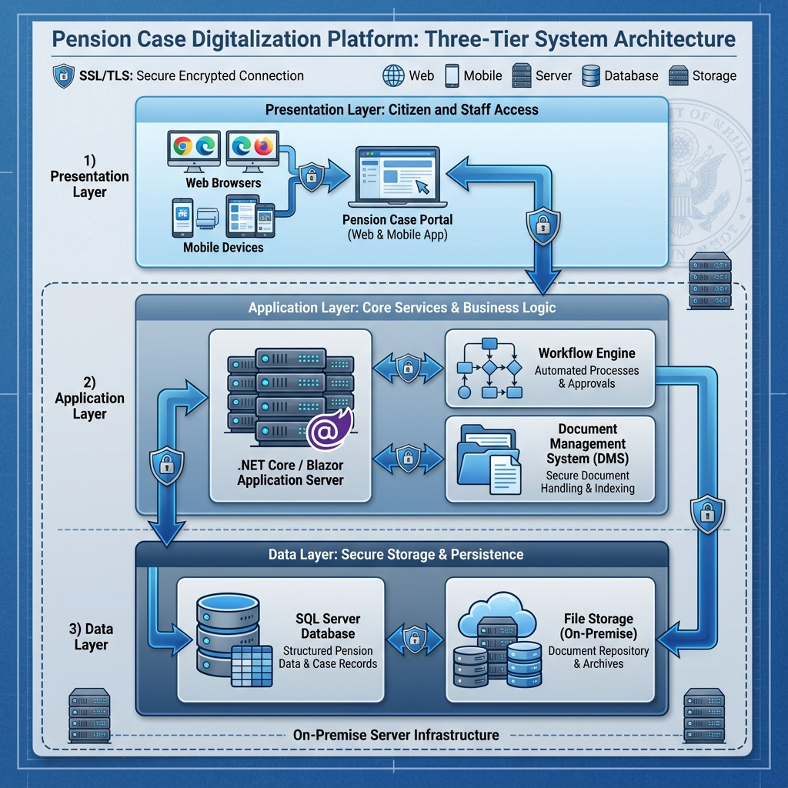

Functional Requirements

Pension Case Digitization Portal
The system shall provide a comprehensive web-based portal accessible to government employees for submitting pension cases online.
A. Employee Self-Service Features
- User registration with CNIC-based verification
- Secure login with two-factor authentication
- Personalized dashboard showing case status
- Online pension case initiation
- Form auto-save functionality
- Document upload with progress tracking
- Case submission with acknowledgment receipt
- Real-time status tracking
- Notification management (email/SMS)
- Document download/print capabilities
B. Form Management
- Dynamic form generation based on pension type
- Field validation and mandatory checks
- Auto-population from employee database
- Form templates for different pension types
- Multi-step form wizard
- Data validation before submission
- Preview before final submission
C. Document Upload System
- Support for multiple file formats (PDF, JPG, PNG)
- File size limit: Up to 10MB per document
- Multiple document categories
- Document preview functionality
- Mandatory document checklist
- Optional document support
- Batch upload capability
- Upload progress indicator
- Document replacement/update before submission
D. Case Status Tracking
- Real-time case status dashboard
- Timeline view of case progression
- Current approver information
- Expected completion date
- Status change notifications
- Detailed activity log
- Comments/queries from reviewers
- Download case summary

Workflow Automation Engine
A. Approval of Workflow Management
- Configurable multi-level approval process
- Role-based routing (Pension Officer → Superintendent → Deputy Director → Director)
- Automatic case assignment based on workload
- Manual case reassignment capability
- Parallel and sequential approval support
- Conditional routing based on pension type
- Approval delegation during leave/absence
- Escalation rules for pending cases
B. Task Management
- Automated task creation upon case submission
- Task inbox for each approver
- Task priority management
- Pending task reminders
- Overdue task alerts
- Task completion tracking
- Workload distribution reports
C. Notification System
- Email notifications for all status changes
- SMS alerts for critical updates
- In-app notifications
- Customizable notification templates
- Notification preferences management
- Escalation notifications to supervisors
- Batch notifications for multiple cases
D. Audit Trail and Logging
- Complete transaction history
- User activity logging
- System access logs
- Document access tracking
- Approval/rejection reasons
- Timestamp for all actions
- IP address logging
- Export audit reports

Pension Case Types to Support
The system must handle the following pension case types with specific workflows for each:
Pension Type | Description | Required Documents | Estimated Processing Time
**Superannuation Pension** | Regular retirement at age 60 | Service Book, Last Pay Certificate, CNIC, Bank Details, Nomination Form | 30 days
**Voluntary Retirement Pension** | Early retirement (25+ years service) | Service Certificate, Last Pay Certificate, CNIC, Bank Details, Application, Nomination Form | 45 days
**Invalid/Medical Pension** | Retirement due to medical reasons | Service Book, Medical Board Certificate, Last Pay Certificate, CNIC, Bank Details, Nomination Form | 60 days
**Family/Survivor Pension** | Pension to family after employee death | Death Certificate, Service Book, Heir Certificate, Family CNIC Copies, Bank Details, Nomination Form | 60 days
**Commutation of Pension** | Lump-sum withdrawal option | Pension Payment Order, Medical Certificate, Bank Details, Application Form | 30 days

Document Requirements by Case Type
A. Common Documents (All Cases):
- National Identity Card (CNIC) - Employee
- Last Pay Certificate (LPC)
- Bank Account Details (IBAN)
- Passport-size Photographs (2)
- Nomination Form (for family pension)
B. Superannuation Pension Specific:
- Complete Service Book (certified)
- Service Certificate from last department
- No Dues Certificate
- General Provident Fund (GPF) statement
C. Voluntary Retirement Specific:
- Service Certificate (minimum 25 years)
- Voluntary Retirement Application
- Department clearance certificate
- GPF statement
D. Invalid/Medical Pension Specific:
- Medical Board Certificate
- Medical history documents
- Disability certificate (if applicable)
- Doctor's recommendation
E. Family/Survivor Pension Specific:
- Death Certificate (original)
- Heir-ship Certificate/Succession Certificate
- CNIC copies of all legal heirs
- Marriage certificate (widow's pension)
- Birth certificates (minor children)
- Educational certificates (children 21-25 years)
F. Commutation Specific:
- Original Pension Payment Order (PPO)
- Medical fitness certificate
- Commutation calculation form
- Life certificate

User Roles and Permissions
Role | Responsibilities | Access Level
**Employee** | Submit pension cases, upload documents, track status | Portal access, own cases only
**Pension Officer** | Initial verification, document checking, forwarding | View/edit assigned cases, verification tools
**Superintendent** | Review verified cases, approve/reject, forward | View/edit departmental cases, approval authority
**Deputy Director** | Secondary approval, policy compliance check | View all cases, approval authority, reassignment
**Director Finance** | Final approval, policy decisions | Full system access, all approvals, configuration
**System Administrator** | User management, system configuration, reports | Complete system access, all modules
**Data Entry Operator** | Assist employees, manual data entry if needed | Portal access, data entry only
**Audit Officer** | Review audit trails, compliance checking | Read-only access, audit reports

3.6.7 Non-Functional Requirements

Performance Requirements
- Response Time: Page load within 2 seconds under normal load
- Concurrent Users: Support minimum 500 concurrent users
- Database Transactions: Process 100 transactions per second
- Document Upload: Complete 10MB upload within 30 seconds
- Search Results: Return search results within 1 second
- Report Generation: Generate standard reports within 60 seconds

Availability and Reliability
- System Uptime: 99.5% availability (excluding planned maintenance)
- Planned Maintenance: Maximum 4 hours per month (off-peak hours)
- Data Backup: Daily automated backups with 30-day retention
- Disaster Recovery: Recovery Time Objective (RTO) of 24 hours
- Recovery Point Objective: Maximum 1 hour data loss tolerance

Security Requirements
- Authentication: Multi-factor authentication for all users
- Authorization: Role-based access control (RBAC)
- Data Encryption: TLS 1.2+ for data in transit, AES-256 for data at rest
- Password Policy: Minimum 8 characters, complexity requirements, 90-day expiry
- Session Management: Auto-logout after 15 minutes of inactivity
- Audit Logging: All user actions logged and tamper-proof
- Data Privacy: Compliance with Pakistan Electronic Data Protection Act

Usability Requirements
- User Interface: Intuitive, modern, responsive design
- Language Support: English and Urdu interface
- Accessibility: WCAG 2.1 Level AA compliance
- Help System: Context-sensitive help and user manuals
- Training: Minimal training required (maximum 2 days for basic users)

Scalability Requirements
- User Growth: Support 50% annual user growth for 5 years
- Data Growth: Handle 10,000 new cases per year
- Document Storage: Support 10TB initial, expandable to 100TB
- Modular Design: Allow addition of new pension types without core system changes
________________________________________________________________________________

SECTION 3.6.8: TECHNICAL SPECIFICATIONS

Technology Stack

Application Development
- Framework: .NET Core 6.0 or higher / Blazor
OR
Modern web framework (React/Angular/Vue.js with Node.js backend)
- Backend Language: C# (.NET) or TypeScript/JavaScript (Node.js)
- UI Framework: Blazor / React / Angular / Vue.js
- API Architecture: RESTful APIs with OpenAPI/Swagger documentation
- Authentication: OAuth 2.0 / OpenID Connect or JWT-based authentication

Database
- Primary Database: Microsoft SQL Server 2019 or higher
- ORM: Entity Framework Core (for .NET) or Sequelize/TypeORM (for Node.js)
- Database Design: Normalized schema with referential integrity
- Full-Text Search: SQL Server Full-Text Search capability

Document Storage
- File Storage: Dedicated file server with hierarchical folder structure
- Document Database: Metadata stored in SQL Server, files in file system
- Supported Formats: PDF, JPG, PNG, DOCX (read-only conversion to PDF)
- Virus Scanning: Integrated antivirus scanning before storage
- File Compression: Automatic compression for large documents

Infrastructure Requirements
C. Software Requirements:
- Windows Server 2019/2022 or Linux (Ubuntu 20.04 LTS / CentOS 8)
- Microsoft SQL Server 2019 Enterprise Edition
- IIS 10 / Nginx / Apache web server
- SSL/TLS certificates (to be provided by vendor)
- Antivirus software with latest definitions
- Backup software (CommVault / Veeam / equivalent)

Security Architecture

Application Security
- Input Validation: Server-side validation for all user inputs
- SQL Injection Protection: Parameterized queries, no dynamic SQL
- XSS Protection: Output encoding, Content Security Policy headers
- CSRF Protection: Anti-forgery tokens for all state-changing operations
- File Upload Security: File type validation, virus scanning, size limits
- Secure Headers: HSTS, X-Frame-Options, X-Content-Type-Options

Data Security
- Encryption at Rest: AES-256 encryption for sensitive database columns
- Encryption in Transit: TLS 1.2+ for all communications
- Key Management: Secure key storage, rotation policy
- Data Masking: Sensitive data masked in logs and error messages
- Backup Encryption: Encrypted backups with secure storage

Access Control
- Authentication: Multi-factor authentication (MFA) for all users
- Authorization: Role-Based Access Control (RBAC) with least privilege
- Session Security: Secure session tokens, auto-logout, device tracking
- Password Security: Bcrypt/PBKDF2 hashing, password history, complexity rules
- Account Lockout: Auto-lock after 5 failed attempts, unlock via admin

Audit and Monitoring
- Activity Logging: All user actions logged with timestamp, IP, user ID
- Security Logging: Failed login attempts, unauthorized access attempts
- Audit Reports: Exportable audit trails for compliance
- Real-time Monitoring: Dashboard for security events
- Alerts: Email/SMS alerts for suspicious activities

3.6.9 Integration Requirements

Employee Database Integration
- Integration with existing GoB employee database (if available)
- Employee master data synchronization
- Service record verification
- Real-time employee validation during registration

Notification Services
- Email Integration: SMTP server integration for email notifications
- SMS Integration: SMS gateway integration for text alerts
- Notification Templates: Configurable email/SMS templates
- Delivery Tracking: Track notification delivery status

Payment System Integration (Future)
- API endpoints for pension payment system integration
- Standardized data exchange formats
- Secure API authentication

3.6.10 System Quality Attributes

Performance Specifications
- Application Server Response: < 2 seconds for 95% of requests
- Database Query Time: < 500ms for standard queries
- Document Upload Speed: > 1 MB/second
- Concurrent Sessions: 500+ users without degradation
- Peak Load Handling: 2x normal load during month-end

Browser Compatibility
- Desktop Browsers:
- Google Chrome (latest 2 versions)
- Mozilla Firefox (latest 2 versions)
- Microsoft Edge (latest 2 versions)
- Safari (latest version for macOS)
- Mobile Browsers:
- Chrome Mobile (Android)
- Safari Mobile (iOS)
- Screen Resolutions: Responsive design for 1024x768 to 4K displays

Mobile Responsiveness
- Fully responsive design for tablets and smartphones
- Touch-friendly interface elements
- Mobile-optimized document upload
- Progressive Web App (PWA) capability preferred

3.6.11 Reporting and Analytics

Standard Reports
- Daily Summary Report: Cases submitted, approved, pending
- Pending Cases Report: Cases by status and aging
- User Activity Report: Login history, submission statistics
- Department-wise Report: Cases by employee department
- Document Verification Report: Document accuracy statistics
- SLA Compliance Report: Processing time vs targets
- Monthly Performance Report: Comprehensive monthly metrics

Dashboard Requirements
- Executive Dashboard: High-level KPIs and trends (for Director)
- Operational Dashboard: Real-time case status (for officers)
- Employee Dashboard: Personal case tracking (for employees)
- Visual Analytics: Charts, graphs, trend lines
- Export Capabilities: PDF, Excel, CSV export

Ad-hoc Query Tool
- User-friendly report builder
- Pre-defined templates
- Custom filter options
- Scheduled report generation
- Email delivery of reports
________________________________________________________________________________

SECTION 3.6.12: IMPLEMENTATION APPROACH
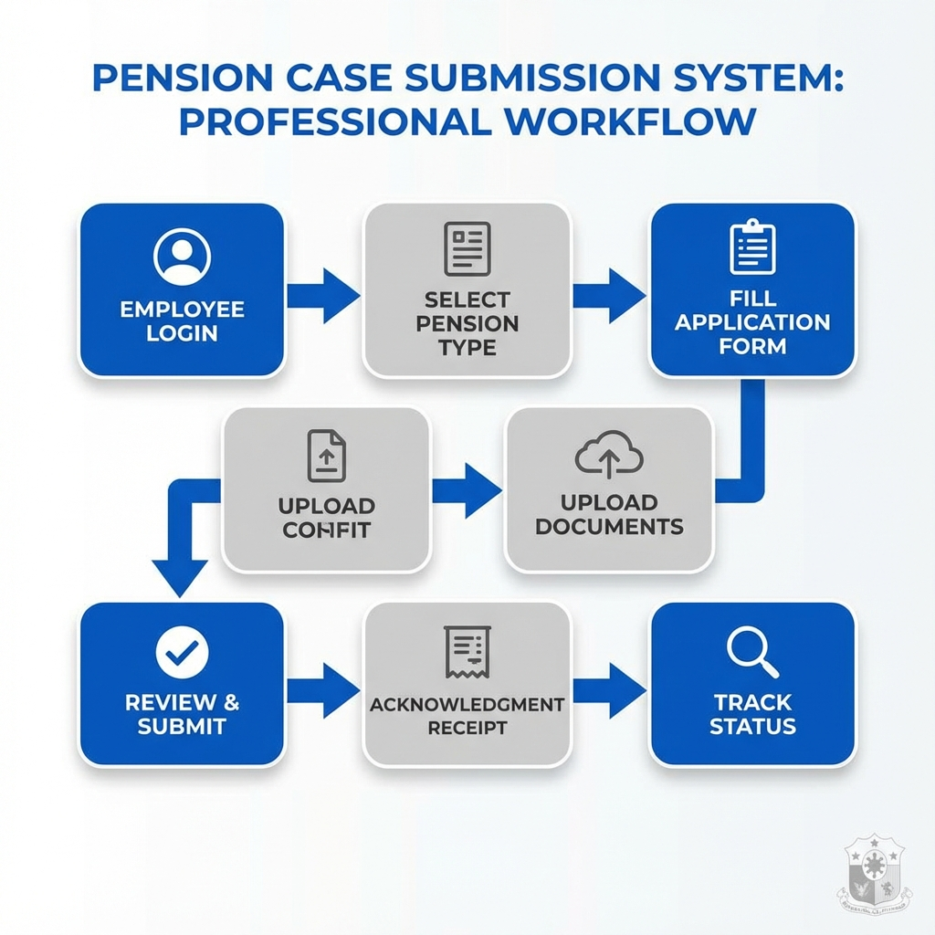

4.1 Project Duration and Methodology

4.1.1 Overall Timeline
- Total Project Duration: 12-15 months from contract signing
- Development Methodology: Agile with 2-week sprints
- Delivery Approach: Incremental delivery with milestone-based acceptance

4.1.2 Project Phases
Phase | Duration | Key Deliverables
**Phase 1: Requirements & Design** | 2 months | Requirements Document, System Design, Database Schema, UI/UX Mockups
**Phase 2: Development** | 6 months | Core System, Employee Portal, Workflow Engine, Admin Module, Integration
**Phase 3: Testing** | 2 months | Test Cases, UAT, Performance Testing, Security Testing
**Phase 4: Deployment** | 1 month | Production Deployment, Data Migration, Go-Live
**Phase 5: Stabilization & Support** | 2 months | Bug Fixes, Performance Tuning, User Support

4.2 Detailed Phase Breakdown

Phase 1: Requirements and Design (Months 1-2)
Activities:
- Kick-off meeting with stakeholders
- Detailed requirements gathering workshops
- As-Is process documentation
- To-Be process design
- Database schema design
- UI/UX wireframes and mockups
- Technical architecture design
- Security architecture design
- Integration design
- Test strategy preparation
Deliverables:
- Business Requirements Document (BRD)
- Functional Requirements Specification (FRS)
- Technical Design Document (TDD)
- Database Design Document
- UI/UX Design Mockups (approved)
- Project Plan with milestones
- Test Strategy Document
Acceptance Criteria:
- All documents reviewed and approved by GoB
- At least 3 design review meetings conducted
- Sign-off on UI/UX mockups

Phase 2: Development (Months 3-8)
Sprint-wise Development (12 sprints of 2 weeks each):
Sprints 1-2: Foundation
- Development environment setup
- Database creation
- Authentication module
- User management module
Sprints 3-4: Employee Portal
- Employee registration
- Login and security
- Dashboard development
- Profile management
Sprints 5-6: Pension Case Submission
- Form builder for all pension types
- Document upload functionality
- Case submission workflow
- Acknowledgment generation
Sprints 7-8: Workflow Engine
- Approval workflow implementation
- Task management module
- Notification system (email/SMS)
- Case routing logic
Sprints 9-10: Admin and Reports
- Administrative portal
- Role and permission management
- Report generation module
- Dashboard analytics
Sprints 11-12: Integration and Polish
- Employee database integration
- System integration testing
- Performance optimization
- UI/UX refinements
Deliverables (Per Sprint):
- Working software increment
- Sprint demo to stakeholders
- Updated documentation
- Unit test coverage report

Phase 3: Testing (Months 9-10)
Testing Activities:
A. Functional Testing
- Test case creation for all features
- Manual testing of all workflows
- Regression testing after each fix
- Cross-browser compatibility testing
- Mobile responsiveness testing
B. User Acceptance Testing (UAT)
- UAT planning and preparation
- UAT environment setup
- UAT execution with Finance Department staff
- Defect tracking and resolution
- UAT sign-off
C. Performance Testing
- Load testing (500+ concurrent users)
- Stress testing (peak load scenarios)
- Endurance testing (sustained load)
- Database performance tuning
- Performance optimization
D. Security Testing
- Vulnerability assessment
- Penetration testing
- Security code review
- Compliance verification
- Security audit report
Deliverables:
- Test Case Repository
- UAT Test Results
- Performance Test Report
- Security Assessment Report
- Defect Resolution Report

Phase 4: Deployment (Month 11)
Activities:
- Production environment setup
- Hardware installation and configuration
- Software installation
- Database migration
- Production deployment
- Smoke testing in production
- Go-Live preparation
- Cutover execution
Deliverables:
- Production Environment Documentation
- Deployment Checklist
- Go-Live Plan
- Rollback Plan
- Production Deployment Report

Phase 5: Stabilization and Support (Months 12-13)
Activities:
- Post-Go-Live monitoring
- Bug fixing and hot fixes
- Performance tuning
- User support (help desk)
- Feedback collection
- System optimization
- Documentation updates
Deliverables:
- Post-Go-Live Report
- Performance Metrics Report
- User Feedback Analysis
- System Optimization Report

4.3 Training Requirements

4.3.1 Training Plan
A. End User Training (Employees)
- Target Audience: 5,000+ GoB employees (retiring in next 2 years)
- Duration: 2-hour sessions
- Method: Online training videos, user guides, FAQs
- Content: Registration, case submission, document upload, status tracking
B. Administrative User Training (Finance Staff)
- Target Audience: 200+ Finance Department staff
- Duration: 2-day hands-on workshops
- Method: In-person training with practice exercises
- Content:
- Day 1: System overview, case verification, approval workflow
- Day 2: Reports, administration, troubleshooting
C. System Administrator Training
- Target Audience: 5-10 IT staff
- Duration: 5-day comprehensive training
- Method: Hands-on technical workshop
- Content:
- System architecture and components
- User and role management
- System configuration
- Database administration
- Backup and recovery
- Monitoring and troubleshooting
- Security management
D. Training Deliverables:
- User Training Manual (English & Urdu)
- Administrator Training Manual
- Online training videos (10-15 videos)
- Quick Reference Guides
- FAQ Document
- Training attendance records

4.4 Change Management
- Stakeholder communication plan
- User adoption strategy
- Phased rollout approach
- Feedback mechanism
- Continuous improvement process

4.5 Warranty and Support

4.5.1 Warranty Period
- Duration: 24 months from Go-Live date
- Coverage: All bugs, defects, and system failures
- Response Time:
- Critical issues: 2 hours
- High priority: 8 hours
- Medium priority: 24 hours
- Low priority: 72 hours
- Resolution Time:
- Critical: 8 hours
- High: 24 hours
- Medium: 5 days
- Low: 10 days

4.5.2 Support Services
- Help Desk: Dedicated support team (8 AM - 6 PM, Mon-Fri)
- On-Site Support: 2 engineers available at Finance Department
- Remote Support: 24/7 for critical issues
- Bug Fixes: Free during warranty period
- Minor Enhancements: Up to 200 person-hours included
- System Updates: Security patches and minor version updates

SECTION 4: TECHNICAL SPECIFICATIONS

4.1 TECHNOLOGY STACK REQUIREMENTS

Mandatory Technology Stack
Layer | Required Technology | Rationale
**Backend Framework** | **.NET Core 6.0+** | Modern, cross-platform, high-performance
**Web Frontend** | **Blazor (Server/WebAssembly)** | Component-based, C# throughout, seamless integration
**Mobile Framework** | **Flutter** or **React Native** | Cross-platform, native performance
**Database (RDBMS)** | **PostgreSQL 14+** or **SQL Server 2019+** | Enterprise-grade, robust, scalable
**API Architecture** | **RESTful APIs (.NET Core Web API)** | Standard, well-documented, interoperable
**Authentication** | **OAuth 2.0 / OpenID Connect** | Industry standard, secure
**Caching** | **Redis** | Performance optimization
**Message Queue** | **RabbitMQ** or **Azure Service Bus** | Reliable async processing
**Search Engine** | **Elasticsearch** | Full-text search, analytics
**Document Storage** | **MinIO** or **Azure Blob Storage** | Scalable object storage

AI/ML Components
Component | Technology | Purpose
**NLP Engine** | Python + FastAPI | Document generation, text analysis
**ML Framework** | TensorFlow / PyTorch | Custom model training
**OCR Engine** | Tesseract / Commercial OCR | Document digitization

Frontend Technologies
Technology | Use Case
**HTML5 / CSS3** | Modern web standards
**Bootstrap 5** | Responsive design framework
**JavaScript / TypeScript** | Client-side functionality
**Chart.js / D3.js** | Data visualization

4.2 INTEGRATION ARCHITECTURE

System Integration Map
*Figure 3: System Integration Architecture - Comprehensive integration map showing core systems, external systems, and the integration layer with API gateways, message queues, and security components.*

Integration Standards
Integration Type | Protocol | Format | Security
**REST APIs** | HTTPS | JSON | OAuth 2.0 + TLS 1.3
**Web Services** | HTTPS | SOAP/XML | WS-Security
**File Transfer** | SFTP | Various | SSH + Encryption
**Message Queue** | AMQP | JSON/XML | TLS + Authentication
**Database** | TCP/IP | Native | Encrypted connection

4.3 SECURITY FRAMEWORK

Multi-Layer Security Architecture
*Figure 4: Multi-Layer Security Architecture - Comprehensive defense-in-depth security model with network, application, data, and physical security layers, plus continuous monitoring and compliance.*

Security Requirements
Category | Requirement | Implementation
**Authentication** | Multi-factor authentication for sensitive operations | OAuth 2.0 + OTP/Biometric
**Authorization** | Role-based access control (RBAC) | Custom authorization policies
**Data Encryption** | All data encrypted at rest | AES-256 encryption
**Communication** | All API calls encrypted in transit | TLS 1.3
**Session Management** | Secure session handling | JWT tokens with expiry
**Audit Logging** | Complete audit trail | All actions logged
**Password Policy** | Strong password requirements | Min 12 chars, complexity rules
**API Security** | Rate limiting, throttling | API Gateway controls
**Vulnerability** | Regular security assessments | Quarterly penetration testing
**Compliance** | ISO 27001 compliance | Security management system

Data Classification
Level | Description | Security Controls
**Confidential** | CM directives, financial data | Highest security, MFA required, encrypted
**Internal** | Employee records, department files | Standard security, authentication required
**Public** | Published notifications, circulars | Basic security, publicly accessible

4.4 INFRASTRUCTURE REQUIREMENTS

Server Specifications
Server Type | Qty | Specifications | Purpose
**Application Servers** | 4 | • 2x Intel Xeon processors (24 cores)  • 256GB RAM  • 2TB NVMe SSD  • Dual 10Gbps NICs | Host application services
**Database Servers** | 2 | • 2x Intel Xeon processors (28 cores)  • 512GB RAM  • 4TB NVMe SSD (RAID 10)  • Dual 25Gbps NICs | Primary and replica databases
**File Storage Servers** | 2 | • 2x Intel Xeon processors  • 128GB RAM  • 100TB SAS HDD (RAID 6)  • Dual 10Gbps NICs | Store documents and files
**Backup Servers** | 2 | • Adequate processing  • 200TB storage  • High-speed connectivity | Backup and disaster recovery

Network Infrastructure
Component | Specification | Quantity
**Core Switches** | 40Gbps backbone, Layer 3 | 2 (redundant)
**Firewalls** | Next-gen firewall, IDS/IPS | 2 (HA pair)
**Load Balancers** | Application load balancer | 2 (HA pair)
**VPN Gateway** | Secure remote access | 2 (redundant)
**Wireless Access Points** | Enterprise-grade, 802.11ax | As needed

[

SECTION 5: IMPLEMENTATION FRAMEWORK

5.1 PROJECT METHODOLOGY

Agile-Waterfall Hybrid Approach
The project will follow a **hybrid methodology** combining:
- **Waterfall phases** for overall project structure and planning
- **Agile sprints** for software development and iterative delivery
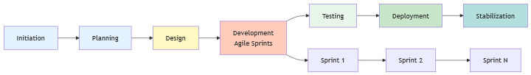

Project Phases
Phase | Duration | Key Activities | Deliverables
**Phase 1: Initiation & Planning** | Months 1-2 | • Project kickoff  • Team mobilization  • Requirements gathering  • Risk assessment | • Project charter  • Requirements document  • Risk register
**Phase 2: Design** | Months 3-4 | • System architecture  • Database design  • UI/UX design  • Integration design | • Architecture document  • Design specifications  • Wireframes
**Phase 3: Development** | Months 5-14 | • Agile sprints (2 weeks each)  • Continuous integration  • Code reviews  • Unit testing | • Working software  • Source code  • Technical documentation
**Phase 4: Testing** | Months 15-17 | • System testing  • Integration testing  • Performance testing  • UAT | • Test reports  • Bug fixes  • UAT sign-off
**Phase 5: Deployment** | Months 18-20 | • Infrastructure setup  • Data migration  • Pilot deployment  • Full rollout | • Deployed systems  • Migration reports  • Go-live certification
**Phase 6: Stabilization** | Months 21-24 | • Performance tuning  • Issue resolution  • User support  • Knowledge transfer | • Stable production system  • Final documentation  • Project closure report

Agile Development Sprints
Sprint Structure (2 weeks):
Day | Activity
**Day 1** | Sprint planning - Select user stories, commit to deliverables
**Days 2-9** | Development - Daily standups (15 min), continuous coding
**Day 10** | Sprint review - Demo completed features to stakeholders
**Day 10 (afternoon)** | Sprint retrospective - Discuss improvements

5.2 TIMELINE AND MILESTONES

Master Project Timeline
Month 1-2: [████████] Initiation & Planning
Month 3-4: [████████] Design Phase
Month 5-14: [████████████████████████████████] Development (20 sprints)
Month 15-17: [████████] Testing
Month 18-20: [████████] Deployment
Month 21-24: [████████] Stabilization

Critical Milestones
Milestone | Target Month | Success Criteria
**M1: Project Kickoff** | Month 1 | • Contract signed  • Team mobilized  • Governance established
**M2: Requirements Approval** | Month 2 | • Requirements documented  • Stakeholder sign-off  • Scope frozen
**M3: Design Approval** | Month 4 | • Architecture approved  • UI/UX finalized  • Tech stack confirmed
**M4: Development Complete** | Month 14 | • All features developed  • Code review complete  • Ready for testing
**M5: Testing Complete** | Month 17 | • All tests passed  • UAT sign-off  • Production ready
**M6: Data Migration Complete** | Month 19 | • All data migrated  • Data validated  • Reconciliation complete
**M7: System Go-Live** | Month 20 | • Systems deployed  • Users trained  • Production support active
**M8: Project Closure** | Month 24 | • All deliverables accepted  • Knowledge transferred  • Lessons documented

System-Specific Development Schedule
System | Development Start | Development End | Testing | Go-Live
**FMIS** | Month 5 | Month 13 | Months 14-16 | Month 20
**EFMS** (integrated) | Month 5 | Month 13 | Months 14-16 | Month 20
**PAMS** | Month 6 | Month 14 | Months 15-17 | Month 20
**CMDS** | Month 8 | Month 12 | Months 13-14 | Month 18
**SAS** | Month 9 | Month 13 | Months 14-15 | Month 19

5.3 QUALITY ASSURANCE

Testing Strategy
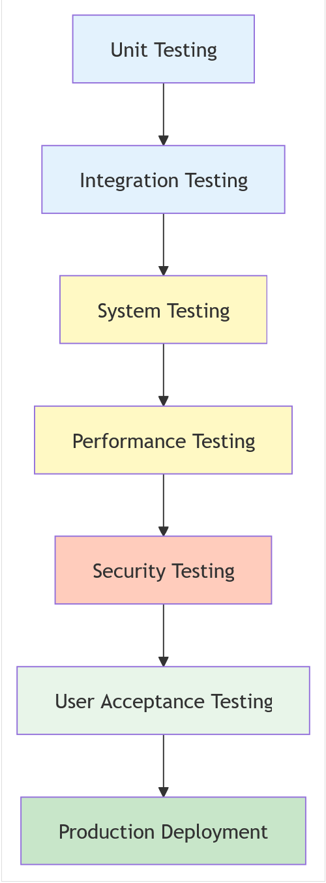

Testing Types and Coverage
Testing Type | Coverage Target | Tools/Methods | Responsibility
**Unit Testing** | 80%+ code coverage | NUnit / xUnit | Developers
**Integration Testing** | All API endpoints | Postman / Integration tests | QA Team
**Functional Testing** | All features | Manual + Automated | QA Team
**Performance Testing** | Load, stress, endurance | JMeter / LoadRunner | Performance Team
**Security Testing** | OWASP Top 10 | SAST, DAST, Penetration testing | Security Team
**UAT** | All user scenarios | Manual testing | End Users + PMO
**Regression Testing** | Critical paths | Automated test suite | QA Team

Quality Metrics
Metric | Target | Measurement Method
**Code Coverage** | ≥ 80% | Code analysis tools
**Defect Density** | ≤ 5 defects per 1000 LOC | Defect tracking system
**Critical Defects** | 0 in production | Defect severity tracking
**Test Pass Rate** | ≥ 95% | Test execution results
**Mean Time to Fix** | < 48 hours (critical), < 1 week (major) | Defect lifecycle tracking
**User Acceptance** | ≥ 90% satisfaction | UAT feedback surveys

Defect Management
Severity Levels:
Level | Description | Response Time | Resolution Time
**Critical** | System down, major functionality broken | 1 hour | 4 hours
**High** | Major feature not working, workaround exists | 4 hours | 24 hours
**Medium** | Minor feature issue, no workaround | 24 hours | 1 week
**Low** | Cosmetic issues, enhancement requests | 1 week | Next release

5.4 TRAINING AND SUPPORT

Training Strategy
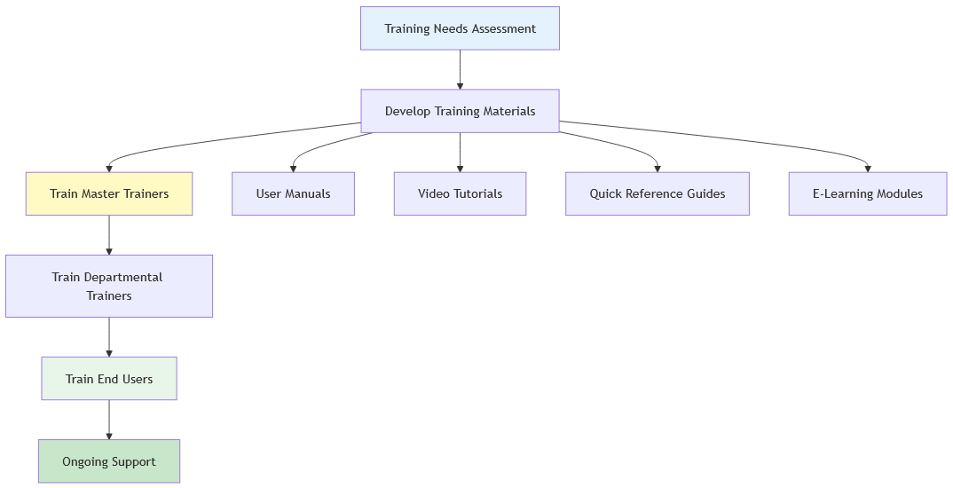

Training Program
Training Level | Audience | Duration | Method | Count
**Master Trainers** | IT team, super users | 5 days | Intensive classroom | 20 persons
**Departmental Trainers** | Department representatives | 3 days | Classroom + hands-on | 100 persons
**System Administrators** | IT administrators | 5 days | Technical deep-dive | 15 persons
**End Users (Basic)** | All government employees | 2 days | Classroom + e-learning | 2,000+ persons
**End Users (Advanced)** | Power users, managers | 3 days | Classroom + scenarios | 500 persons
**Executive Users** | Secretaries, CM Office | 2 hours | Personalized demo | 50 persons

Training Materials
All training materials will be provided in **English** and **Urdu**:
- **User Manuals** - Comprehensive guides for each system (200+ pages per system)
- **Quick Reference Guides** - One-page cheat sheets for common tasks
- **Video Tutorials** - 5-10 minute videos for each major feature (50+ videos)
- **E-Learning Modules** - Interactive self-paced courses
- **FAQ Documents** - Common questions and answers
- **Troubleshooting Guides** - Step-by-step problem resolution

Support Structure
Three-Tier Support Model:
┌────────────────────────────────────────┐
│ TIER 1: Help Desk │
│ • First point of contact │
│ • Password resets │
│ • Basic troubleshooting │
│ • Ticket logging │
│ • Response: Immediate │
└────────────────────────────────────────┘
↓ Escalation
┌────────────────────────────────────────┐
│ TIER 2: Technical Support │
│ • Application issues │
│ • Configuration problems │
│ • Data issues │
│ • Integration problems │
│ • Response: 2-4 hours │
└────────────────────────────────────────┘
↓ Escalation
┌────────────────────────────────────────┐
│ TIER 3: Development Team │
│ • Critical bugs │
│ • System failures │
│ • Complex technical issues │
│ • Code fixes │
│ • Response: 1 hour (critical) │
└────────────────────────────────────────┘

Support Channels
Channel | Availability | Purpose
**Phone Help Desk** | 8 AM - 6 PM (Mon-Fri) | Immediate assistance
**Email Support** | 24/7 (response within 4 hours) | Non-urgent queries
**Online Portal** | 24/7 | Ticket submission, knowledge base
**Live Chat** | 9 AM - 5 PM (Mon-Fri) | Quick questions
**On-site Support** | First 3 months post go-live | Complex issues, training

Warranty and Maintenance (36 Months)
Included Services:
- **Bug Fixes** - All software defects fixed at no cost
- **System Maintenance** - Regular updates, patches, optimization
- **Help Desk Support** - Unlimited support tickets
- **Minor Enhancements** - Small improvements and adjustments
- **Performance Tuning** - Optimize system performance
- **Security Updates** - Critical security patches
- **Backup Management** - Regular backups and recovery testing
- **Health Monitoring** - 24/7 system monitoring
Service Level Agreement (SLA):
Metric | Target
System Availability | 99.5% uptime
Response Time (Critical) | 1 hour
Response Time (High) | 4 hours
Response Time (Medium) | 24 hours
Mean Time to Resolve (Critical) | 4 hours
Mean Time to Resolve (High) | 24 hours

SECTION 6: TERMS AND CONDITIONS

6.1 GENERAL TERMS

Contract Type and Duration
Item | Details
**Contract Type** | Fixed-price for development, time & materials for support
**Implementation Duration** | 18-24 months from contract signing
**Warranty Period** | 3 months from final acceptance
**Payment Terms** | Milestone-based payments (details in financial proposal)

Eligibility and Compliance
Mandatory Compliance:
- Compliance with government data protection regulations
- Compliance with labor laws for all personnel

Performance Guarantees
The vendor must provide:
Guarantee Type | Percentage | Validity
**Bid Security** | 2% of estimated project value | 120 days from bid submission
**Performance Bank Guarantee** | 10% of contract value | Throughout implementation + 60 days
**Advance Payment Guarantee** | 100% of advance (if applicable) | Until advance recovered

Liquidated Damages
For delays beyond agreed timelines:
Delay Period | Penalty | Maximum Cap
**Per week delay** | 0.5% of contract value | Maximum 10% total

**Exemptions:** Force majeure events, government-caused delays with documentary proof

6.2 INTELLECTUAL PROPERTY

Ownership
Component | Ownership | Rights
**Custom-Developed Software** | Government of Balochistan | Full ownership, source code included
**Third-Party Software** | Original vendor | Licensed to Government
**Documentation** | Government of Balochistan | Full ownership
**Training Materials** | Government of Balochistan | Full ownership

Source Code Delivery
The vendor must provide:
- **Complete source code** for all custom-developed systems
- **Database schemas** and scripts
- **API documentation** with examples
- **Deployment scripts** and configuration files
- **Technical documentation** for future maintenance
- **Escrow arrangement** for critical third-party components

License Requirements
All software licenses must be:
- **Perpetual licenses** (no subscription-based)
- **Transferable** to Government of Balochistan
- **Enterprise-grade** with no user/device limitations
- **Upgradeable** to newer versions without additional cost during warranty

6.3 WARRANTY AND SUPPORT

Warranty Coverage (36 Months)
Included at No Additional Cost:
Service | Description
**Defect Correction** | Fix all bugs, errors, and defects in software
**Performance Issues** | Resolve performance degradation issues
**Security Patches** | Apply critical security updates
**System Maintenance** | Database optimization, log management, backups
**Help Desk Support** | 8 AM - 6 PM, Monday to Friday
**Remote Support** | 24/7 for critical issues
**On-site Support** | As needed for complex issues

Exclusions from Warranty
Warranty **does not cover**:
- Issues caused by unauthorized modifications by government IT staff
- Hardware failures (covered by hardware warranties)
- Third-party software issues beyond vendor's control
- User errors or misuse
- Force majeure events

Post-Warranty Support
After 36-month warranty period, support will be available through:
- **Annual Maintenance Contract (AMC)** - Negotiated separately
- **On-demand Support** - Pay-per-incident basis

EQUIREMENTS
8.1 Overview
The successful bidder shall be responsible for proposing, procuring, and deploying all necessary infrastructure and hardware components required for the successful implementation and operation of the proposed systems. The Government of Balochistan recognizes that different technical approaches may require different infrastructure configurations, and therefore provides the bidder with full autonomy in determining the optimal hardware architecture.
8.2 Bidder's Responsibility and Autonomy
The bidder shall have complete discretion in proposing the infrastructure and hardware specifications that best align with their technical approach and solution architecture. This includes, but is not limited to, decisions regarding:
- Server architecture (physical, virtual, cloud-based, or hybrid)
- Computing capacity and processing power requirements
- Storage solutions and capacity planning
- Network infrastructure and connectivity requirements
- Database servers and management systems
- Application servers and middleware platforms
- Backup and disaster recovery infrastructure
- Security appliances and monitoring systems
- Load balancing and redundancy mechanisms
- Development, testing, and production environments
8.3 Infrastructure Categories (Indicative)
While the bidder retains full authority over hardware specifications, the following categories are provided as indicative guidance for proposal preparation:
Category | Purpose | Bidder Determination
Server Infrastructure | Application hosting, database management, web services | Type, quantity, specifications
Storage Systems | Data storage, document management, archival | Capacity, technology, redundancy
Network Equipment | Connectivity, routing, switching | Architecture, bandwidth, security
Security Infrastructure | Firewall, intrusion detection, access control | Solutions, configurations, policies
Backup Systems | Data protection, disaster recovery | Strategy, frequency, retention
Monitoring Tools | Performance monitoring, system health | Tools, dashboards, alerting
Development Environment | Testing, staging, development | Configuration, isolation, resources

8.4 Proposal Requirements
The bidder's technical proposal shall include a comprehensive infrastructure plan that addresses the following aspects:
Requirement | Description
Infrastructure Architecture | Detailed architecture diagram showing all hardware components and their interconnections
Hardware Specifications | Complete specifications for all proposed hardware including servers, storage, network equipment
Capacity Planning | Justification for proposed capacity based on expected load, user base, and growth projections
Scalability Strategy | Approach for scaling infrastructure to accommodate future growth and increased demand
High Availability | Redundancy mechanisms, failover strategies, and uptime guarantees
Cost Breakdown | Itemized cost breakdown for all hardware components including procurement, installation, and maintenance

8.5 Deployment Options
The bidder may propose any of the following deployment models or a hybrid approach, based on their technical assessment and cost-benefit analysis:
Deployment Model | Description | Considerations
On-Premise | Hardware deployed at government facilities | Full control, data sovereignty, capital investment
Cloud-Based | Infrastructure hosted on cloud platforms | Scalability, operational expenditure, vendor dependency
Hybrid | Combination of on-premise and cloud | Flexibility, optimized costs, complex management
Managed Services | Third-party managed infrastructure | Reduced operational burden, service level agreements

6.6 Important Note
The infrastructure and hardware requirements are NOT prescriptive. The successful bidder shall have complete authority and responsibility for determining the optimal infrastructure configuration that meets the functional requirements outlined in this RFP. The Government of Balochistan will evaluate proposals based on the technical soundness, cost-effectiveness, and alignment with project objectives, rather than adherence to any specific hardware specifications.

END OF DOCUMENT
Government of Balochistan, Finance Department, Civil Secretariat, Quetta
Contact: Email: it.finance@balochistan.gov.pk Phone: +92-81-XXXXXXX
*This document is the property of the Government of Balochistan. Unauthorized reproduction or distribution is prohibited.*

